

DEPARTMENT OF COMPUTER SCIENCE & ENGINEERING



Course: Machine Learning lab
Course code: BCSL606

Semester: 6
Scheme: 2022

SJC INSTITUTE OF TECHNOLOGY

DEPARTMENT OF COMPUTER SCIENCE & ENGINEERING
CHICKBALLAPUR -562101
2025
SYLLABUS
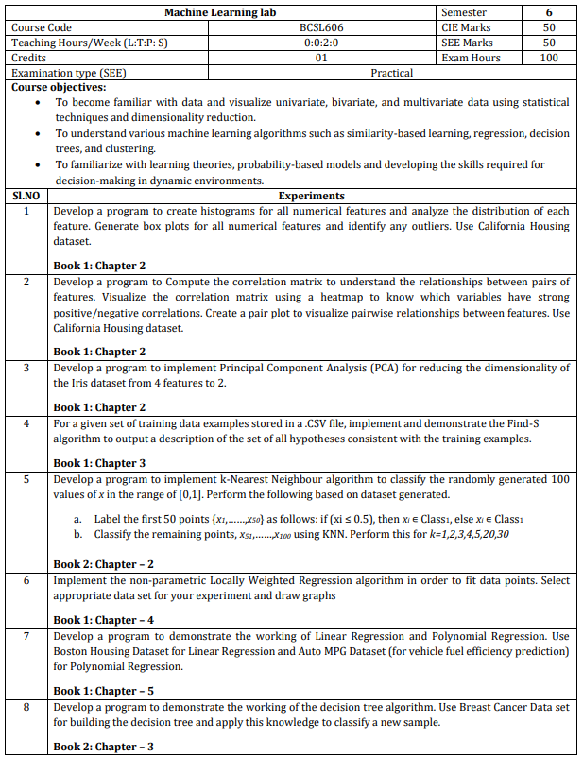





Program 1
Develop a program to create histograms for all numerical features and analyze the distribution of each feature. Generate box plots for all numerical features and identify any outliers. Use California Housing dataset.
import pandas as pd
import numpy as np
import seaborn as sns
import matplotlib.pyplot as plt
from sklearn.datasets import fetch_california_housing

# Step 1: Load the California Housing dataset
data = fetch_california_housing(as_frame=True)
housing_df = data.frame

# Step 2: Create histograms for numerical features
numerical_features = housing_df.select_dtypes(include=[np.number]).columns

# Plot histograms
plt.figure(figsize=(15, 10))
for i, feature in enumerate(numerical_features):
plt.subplot(3, 3, i + 1)
sns.histplot(housing_df[feature], kde=True, bins=30, color='blue')
plt.title(f'Distribution of {feature}')
plt.tight_layout()
plt.show()

# Step 3: Generate box plots for numerical features
plt.figure(figsize=(15, 10))
for i, feature in enumerate(numerical_features):
plt.subplot(3, 3, i + 1)
sns.boxplot(x=housing_df[feature], color='orange')
plt.title(f'Box Plot of {feature}')
plt.tight_layout()
plt.show()
# Step 4: Identify outliers using the IQR method
print("Outliers Detection:")
outliers_summary = {}
for feature in numerical_features:
Q1 = housing_df[feature].quantile(0.25)
Q3 = housing_df[feature].quantile(0.75)
IQR = Q3 - Q1
lower_bound = Q1 - 1.5 * IQR
upper_bound = Q3 + 1.5 * IQR
outliers = housing_df[(housing_df[feature] < lower_bound) | (housing_df[feature] > upper_bound)]
outliers_summary[feature] = len(outliers)
print(f"{feature}: {len(outliers)} outliers")
Output:
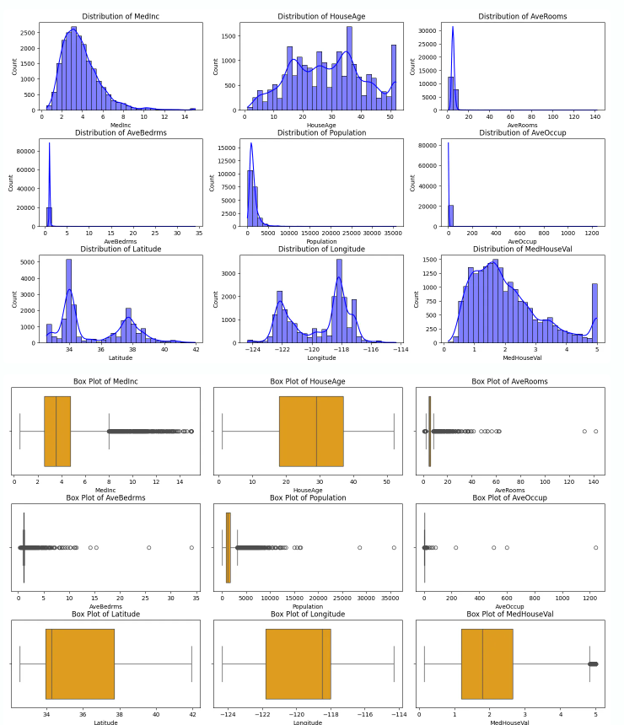

Outliers Detection:
MedInc: 681 outliers
HouseAge: 0 outliers
AveRooms: 511 outliers
AveBedrms: 1424 outliers
Population: 1196 outliers
AveOccup: 711 outliers
Latitude: 0 outliers
Longitude: 0 outliers
MedHouseVal: 1071 outliers

Program 2
Develop a program to Compute the correlation matrix to understand the relationships between pairs of features. Visualize the correlation matrix using a heatmap to know which variables have strong positive/negative correlations. Create a pair plot to visualize pairwise relationships between features. Use California Housing dataset.
import pandas as pd
import seaborn as sns
import matplotlib.pyplot as plt
from sklearn.datasets import fetch_california_housing
# Step 1: Load the California Housing Dataset
california_data = fetch_california_housing(as_frame=True)
data = california_data.frame
# Step 2: Compute the correlation matrix
correlation_matrix = data.corr()
# Step 3: Visualize the correlation matrix using a heatmap
plt.figure(figsize=(10, 8))
sns.heatmap(correlation_matrix, annot=True, cmap='coolwarm', fmt='.2f', linewidths=0.5)
plt.title('Correlation Matrix of California Housing Features')
plt.show()
# Step 4: Create a pair plot to visualize pairwise relationships
sns.pairplot(data, diag_kind='kde', plot_kws={'alpha': 0.5})
plt.suptitle('Pair Plot of California Housing Features', y=1.02)
plt.show()

Output:

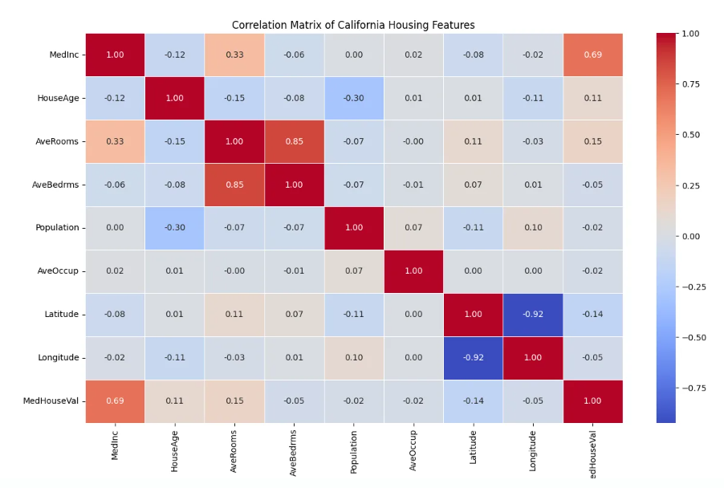

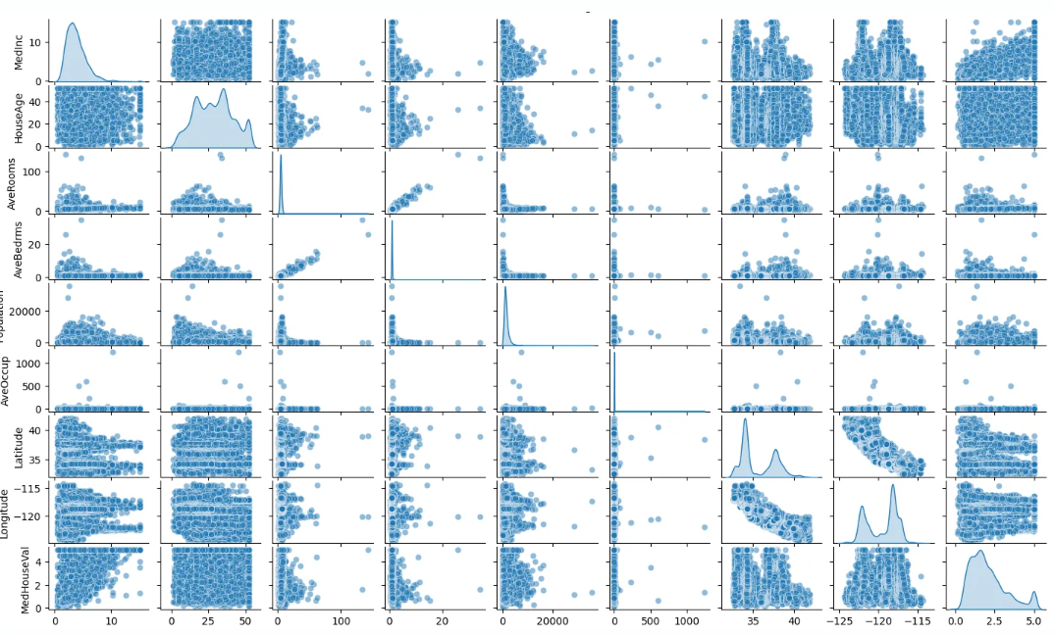
Program 3
Develop a program to implement Principal Component Analysis (PCA) for reducing the dimensionality of the Iris dataset from 4 features to 2.

import numpy as np
import pandas as pd
from sklearn.datasets import load_iris
from sklearn.decomposition import PCA
import matplotlib.pyplot as plt

# Load the Iris dataset
iris = load_iris()
data = iris.data
labels = iris.target
label_names = iris.target_names

# Convert to a DataFrame for better visualization
iris_df = pd.DataFrame(data, columns=iris.feature_names)

# Perform PCA to reduce dimensionality to 2
pca = PCA(n_components=2)
data_reduced = pca.fit_transform(data)

# Create a DataFrame for the reduced data
reduced_df = pd.DataFrame(data_reduced, columns=['Principal Component 1', 'Principal Component 2'])
reduced_df['Label'] = labels

# Plot the reduced data
plt.figure(figsize=(8, 6))
colors = ['r', 'g', 'b']
for i, label in enumerate(np.unique(labels)):
plt.scatter(
reduced_df[reduced_df['Label'] == label]['Principal Component 1'],
reduced_df[reduced_df['Label'] == label]['Principal Component 2'],
label=label_names[label],
color=colors[i]
)

plt.title('PCA on Iris Dataset')
plt.xlabel('Principal Component 1')
plt.ylabel('Principal Component 2')
plt.legend()
plt.grid()
plt.show()

Output:

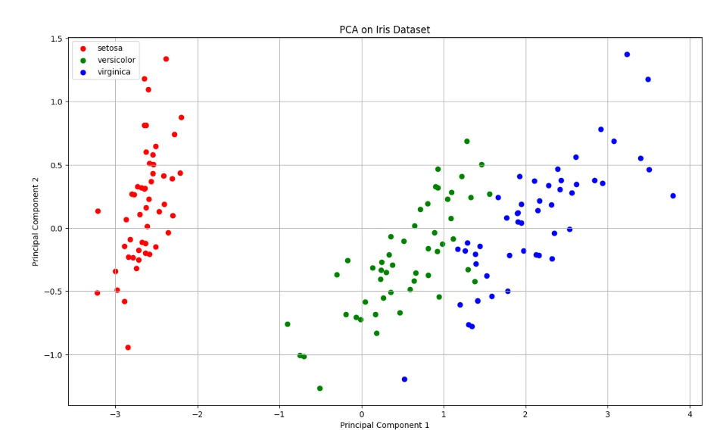

Program 4
For a given set of training data examples stored in a .CSV file, implement and demonstrate the Find-S algorithm to output a description of the set of all hypotheses consistent with the training examples.

Save the below table in .csv file
Outlook | Temperature | Humidity | Windy | PlayTennis
Sunny | Hot | High | FALSE | No
Sunny | Hot | High | TRUE | No
Overcast | Hot | High | FALSE | Yes
Rain | Cold | High | FALSE | Yes
Rain | Cold | High | TRUE | No
Overcast | Hot | High | TRUE | Yes
Sunny | Hot | High | FALSE | No

import pandas as pd

def find_s_algorithm(file_path):
data = pd.read_csv(file_path)

print("Training data:")
print(data)

attributes = data.columns[:-1]
class_label = data.columns[-1]

hypothesis = ['?' for _ in attributes]

for index, row in data.iterrows():
if row[class_label] == 'Yes':
for i, value in enumerate(row[attributes]):
if hypothesis[i] == '?' or hypothesis[i] == value:
hypothesis[i] = value
else:
hypothesis[i] = '?'
return hypothesis
file_path = 'C:/Users/maheit/Desktop/training_data.csv'
hypothesis = find_s_algorithm(file_path)
print("\nThe final hypothesis is:", hypothesis)

Output:

Training data:
Outlook Temperature Humidity Windy PlayTennis
0 Sunny Hot High False No
1 Sunny Hot High True No
2 Overcast Hot High False Yes
3 Rain Cold High False Yes
4 Rain Cold High True No
5 Overcast Hot High True Yes
6 Sunny Hot High False No

The final hypothesis is: ['Overcast', 'Hot', 'High', '?']

Program 5
Develop a program to implement k-Nearest Neighbour algorithm to classify the randomly generated 100 values of x in the range of [0,1]. Perform the following based on dataset generated.
a. Label the first 50 points {x₁,……,x₅₀} as follows: if (xi ≤ 0.5), then xi ∊ Class1, else xi ∊ Class1
b. Classify the remaining points, x₅₁,……,x₁₀₀ using KNN. Perform this for k=1,2,3,4,5,20,30

import numpy as np
import matplotlib.pyplot as plt
from collections import Counter

data = np.random.rand(100)

labels = ["Class1" if x <= 0.5 else "Class2" for x in data[:50]]

def euclidean_distance(x1, x2):
return abs(x1 - x2)

def knn_classifier(train_data, train_labels, test_point, k):
distances = [(euclidean_distance(test_point, train_data[i]), train_labels[i]) for i in range(len(train_data))]

distances.sort(key=lambda x: x[0])
k_nearest_neighbors = distances[:k]

k_nearest_labels = [label for _, label in k_nearest_neighbors]

return Counter(k_nearest_labels).most_common(1)[0][0]

train_data = data[:50]
train_labels = labels

test_data = data[50:]

k_values = [1, 2, 3, 4, 5, 20, 30]

print("--- k-Nearest Neighbors Classification ---")
print("Training dataset: First 50 points labeled based on the rule (x <= 0.5 -> Class1, x > 0.5 -> Class2)")
print("Testing dataset: Remaining 50 points to be classified\n")

results = {}

for k in k_values:
print(f"Results for k = {k}:")
classified_labels = [knn_classifier(train_data, train_labels, test_point, k) for test_point in test_data]
results[k] = classified_labels

for i, label in enumerate(classified_labels, start=51):
print(f"Point x{i} (value: {test_data[i - 51]:.4f}) is classified as {label}")
print("\n")

print("Classification complete.\n")

for k in k_values:
classified_labels = results[k]
class1_points = [test_data[i] for i in range(len(test_data)) if classified_labels[i] == "Class1"]
class2_points = [test_data[i] for i in range(len(test_data)) if classified_labels[i] == "Class2"]

plt.figure(figsize=(10, 6))
plt.scatter(train_data, [0] * len(train_data), c=["blue" if label == "Class1" else "red" for label in train_labels],
label="Training Data", marker="o")
plt.scatter(class1_points, [1] * len(class1_points), c="blue", label="Class1 (Test)", marker="x")
plt.scatter(class2_points, [1] * len(class2_points), c="red", label="Class2 (Test)", marker="x")

plt.title(f"k-NN Classification Results for k = {k}")
plt.xlabel("Data Points")
plt.ylabel("Classification Level")
plt.legend()
plt.grid(True)
plt.show()

Output:
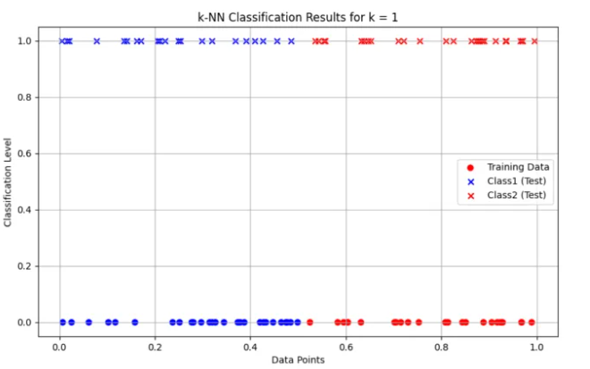
--- k-Nearest Neighbors Classification ---
Training dataset: First 50 points labeled based on the rule (x <= 0.5 -> Class1, x > 0.5 -> Class2)
Testing dataset: Remaining 50 points to be classified

Results for k = 1:
Point x51 (value: 0.2059) is classified as Class1
Point x52 (value: 0.2535) is classified as Class1
Point x53 (value: 0.4856) is classified as Class1
Point x54 (value: 0.9651) is classified as Class2
Point x55 (value: 0.3906) is classified as Class1
Point x56 (value: 0.8903) is classified as Class2
Point x57 (value: 0.9695) is classified as Class2
Point x58 (value: 0.2206) is classified as Class1
Point x59 (value: 0.0203) is classified as Class1
Point x60 (value: 0.1619) is classified as Class1
Point x61 (value: 0.6461) is classified as Class2
Point x62 (value: 0.6523) is classified as Class2
Point x63 (value: 0.8728) is classified as Class2
Point x64 (value: 0.5435) is classified as Class2
Point x65 (value: 0.8246) is classified as Class2
Point x66 (value: 0.9347) is classified as Class2
Point x67 (value: 0.5361) is classified as Class2
Point x68 (value: 0.7215) is classified as Class2
Point x69 (value: 0.9703) is classified as Class2
Point x70 (value: 0.8764) is classified as Class2
Point x71 (value: 0.7543) is classified as Class2
Point x72 (value: 0.1406) is classified as Class1
Point x73 (value: 0.1349) is classified as Class1
Point x74 (value: 0.9705) is classified as Class2
Point x75 (value: 0.2985) is classified as Class1
Point x76 (value: 0.9948) is classified as Class2
Point x77 (value: 0.4551) is classified as Class1
Point x78 (value: 0.2101) is classified as Class1
Point x79 (value: 0.5542) is classified as Class2
Point x80 (value: 0.3202) is classified as Class1
Point x81 (value: 0.6325) is classified as Class2
Point x82 (value: 0.9345) is classified as Class2
Point x83 (value: 0.0156) is classified as Class1
Point x84 (value: 0.8859) is classified as Class2
Point x85 (value: 0.2495) is classified as Class1
Point x86 (value: 0.6380) is classified as Class2
Point x87 (value: 0.7095) is classified as Class2
Point x88 (value: 0.4259) is classified as Class1
Point x89 (value: 0.0052) is classified as Class1
Point x90 (value: 0.6322) is classified as Class2
Point x91 (value: 0.1701) is classified as Class1
Point x92 (value: 0.3693) is classified as Class1
Point x93 (value: 0.4087) is classified as Class1
Point x94 (value: 0.8103) is classified as Class2
Point x95 (value: 0.0773) is classified as Class1
Point x96 (value: 0.8792) is classified as Class2
Point x97 (value: 0.9138) is classified as Class2
Point x98 (value: 0.5567) is classified as Class2
Point x99 (value: 0.8625) is classified as Class2
Point x100 (value: 0.9363) is classified as Class2

Program 6
Implement the non-parametric Locally Weighted Regression algorithm in order to fit data points. Select appropriate data set for your experiment and draw graphs

import numpy as np
import matplotlib.pyplot as plt

def gaussian_kernel(x, xi, tau):
return np.exp(-np.sum((x - xi) ** 2) / (2 * tau ** 2))
def locally_weighted_regression(x, X, y, tau):
m = X.shape[0]
weights = np.array([gaussian_kernel(x, X[i], tau) for i in range(m)])
W = np.diag(weights)
X_transpose_W = X.T @ W
theta = np.linalg.inv(X_transpose_W @ X) @ X_transpose_W @ y
return x @ theta
np.random.seed(42)
X = np.linspace(0, 2 * np.pi, 100)
y = np.sin(X) + 0.1 * np.random.randn(100)
X_bias = np.c_[np.ones(X.shape), X]

x_test = np.linspace(0, 2 * np.pi, 200)
x_test_bias = np.c_[np.ones(x_test.shape), x_test]
tau = 0.5
y_pred = np.array([locally_weighted_regression(xi, X_bias, y, tau) for xi in x_test_bias])

plt.figure(figsize=(10, 6))
plt.scatter(X, y, color='red', label='Training Data', alpha=0.7)
plt.plot(x_test, y_pred, color='blue', label=f'LWR Fit (tau={tau})', linewidth=2)
plt.xlabel('X', fontsize=12)
plt.ylabel('y', fontsize=12)
plt.title('Locally Weighted Regression', fontsize=14)
plt.legend(fontsize=10)
plt.grid(alpha=0.3)
plt.show()

Output:
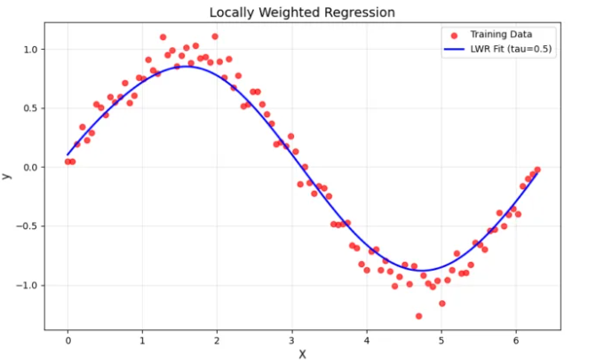

Program 7
Develop a program to demonstrate the working of Linear Regression and Polynomial Regression. Use Boston Housing Dataset for Linear Regression and Auto MPG Dataset (for vehicle fuel efficiency prediction) for Polynomial Regression.
import numpy as np
import pandas as pd
import matplotlib.pyplot as plt
from sklearn.datasets import fetch_california_housing
from sklearn.model_selection import train_test_split
from sklearn.linear_model import LinearRegression
from sklearn.preprocessing import PolynomialFeatures, StandardScaler
from sklearn.pipeline import make_pipeline
from sklearn.metrics import mean_squared_error, r2_score

def linear_regression_california():
housing = fetch_california_housing(as_frame=True)
X = housing.data[["AveRooms"]]
y = housing.target

X_train, X_test, y_train, y_test = train_test_split(X, y, test_size=0.2, random_state=42)

model = LinearRegression()
model.fit(X_train, y_train)

y_pred = model.predict(X_test)

plt.scatter(X_test, y_test, color="blue", label="Actual")
plt.plot(X_test, y_pred, color="red", label="Predicted")
plt.xlabel("Average number of rooms (AveRooms)")
plt.ylabel("Median value of homes ($100,000)")
plt.title("Linear Regression - California Housing Dataset")
plt.legend()
plt.show()

print("Linear Regression - California Housing Dataset")
print("Mean Squared Error:", mean_squared_error(y_test, y_pred))
print("R^2 Score:", r2_score(y_test, y_pred))

def polynomial_regression_auto_mpg():
url = "https://archive.ics.uci.edu/ml/machine-learning-databases/auto-mpg/auto-mpg.data"
column_names = ["mpg", "cylinders", "displacement", "horsepower", "weight", "acceleration", "model_year", "origin"]
data = pd.read_csv(url, sep='\s+', names=column_names, na_values="?")
data = data.dropna()

X = data["displacement"].values.reshape(-1, 1)
y = data["mpg"].values

X_train, X_test, y_train, y_test = train_test_split(X, y, test_size=0.2, random_state=42)

poly_model = make_pipeline(PolynomialFeatures(degree=2), StandardScaler(), LinearRegression())
poly_model.fit(X_train, y_train)

y_pred = poly_model.predict(X_test)

plt.scatter(X_test, y_test, color="blue", label="Actual")
plt.scatter(X_test, y_pred, color="red", label="Predicted")
plt.xlabel("Displacement")
plt.ylabel("Miles per gallon (mpg)")
plt.title("Polynomial Regression - Auto MPG Dataset")
plt.legend()
plt.show()

print("Polynomial Regression - Auto MPG Dataset")
print("Mean Squared Error:", mean_squared_error(y_test, y_pred))
print("R^2 Score:", r2_score(y_test, y_pred))

if __name__ == "__main__":
print("Demonstrating Linear Regression and Polynomial Regression\n")
linear_regression_california()
polynomial_regression_auto_mpg()

Output:
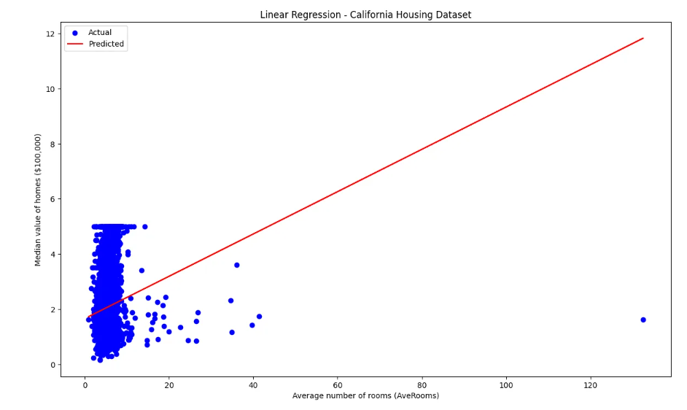
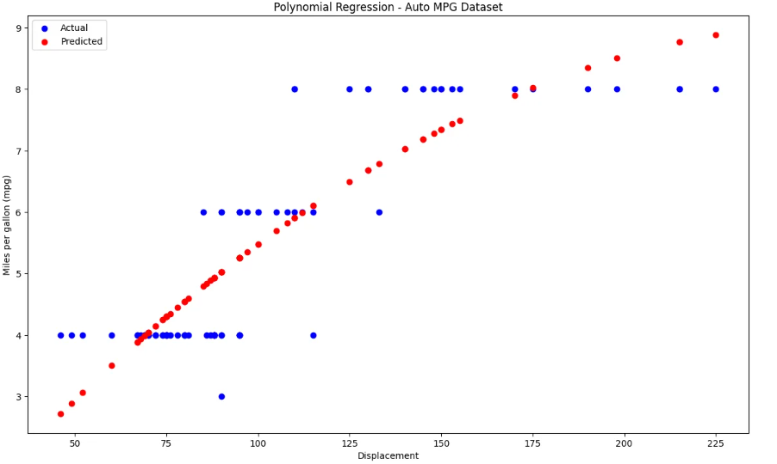
Demonstrating Linear Regression and Polynomial Regression

Linear Regression - California Housing Dataset
Mean Squared Error: 1.2923314440807299
R^2 Score: 0.013795337532284901
Polynomial Regression - Auto MPG Dataset
Mean Squared Error: 0.743149055720586
R^2 Score: 0.7505650609469626

Program 8
Develop a program to demonstrate the working of the decision tree algorithm. Use Breast Cancer Data set for building the decision tree and apply this knowledge to classify a new sample.

import numpy as np
import matplotlib.pyplot as plt
from sklearn.datasets import load_breast_cancer
from sklearn.model_selection import train_test_split
from sklearn.tree import DecisionTreeClassifier
from sklearn.metrics import accuracy_score
from sklearn import tree
data = load_breast_cancer()
X = data.data
y = data.target

X_train, X_test, y_train, y_test = train_test_split(X, y, test_size=0.2, random_state=42)
clf = DecisionTreeClassifier(random_state=42)
clf.fit(X_train, y_train)
y_pred = clf.predict(X_test)

accuracy = accuracy_score(y_test, y_pred)
print(f"Model Accuracy: {accuracy * 100:.2f}%")
new_sample = np.array([X_test[0]])
prediction = clf.predict(new_sample)

prediction_class = "Benign" if prediction == 1 else "Malignant"
print(f"Predicted Class for the new sample: {prediction_class}")

plt.figure(figsize=(12,8))
tree.plot_tree(clf, filled=True, feature_names=data.feature_names, class_names=data.target_names)
plt.title("Decision Tree - Breast Cancer Dataset")
plt.show()

Output:
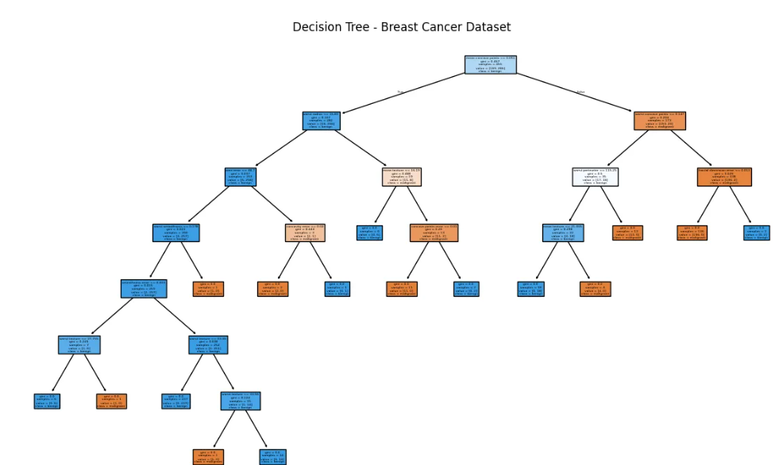
Program 9
Develop a program to implement the Naive Bayesian classifier considering Olivetti Face Data set for training. Compute the accuracy of the classifier, considering a few test data sets.
import numpy as np
from sklearn.datasets import fetch_olivetti_faces
from sklearn.model_selection import train_test_split, cross_val_score
from sklearn.naive_bayes import GaussianNB
from sklearn.metrics import accuracy_score, classification_report, confusion_matrix
import matplotlib.pyplot as plt
data = fetch_olivetti_faces(shuffle=True, random_state=42)
X = data.data
y = data.target
X_train, X_test, y_train, y_test = train_test_split(X, y, test_size=0.3, random_state=42)
gnb = GaussianNB()
gnb.fit(X_train, y_train)
y_pred = gnb.predict(X_test)
accuracy = accuracy_score(y_test, y_pred)
print(f'Accuracy: {accuracy * 100:.2f}%')
print("\nClassification Report:")
print(classification_report(y_test, y_pred, zero_division=1))
print("\nConfusion Matrix:")
print(confusion_matrix(y_test, y_pred))
cross_val_accuracy = cross_val_score(gnb, X, y, cv=5, scoring='accuracy')
print(f'\nCross-validation accuracy: {cross_val_accuracy.mean() * 100:.2f}%')
fig, axes = plt.subplots(3, 5, figsize=(12, 8))
for ax, image, label, prediction in zip(axes.ravel(), X_test, y_test, y_pred):
ax.imshow(image.reshape(64, 64), cmap=plt.cm.gray)
ax.set_title(f"True: {label}, Pred: {prediction}")
ax.axis('off')
plt.show()

Output:
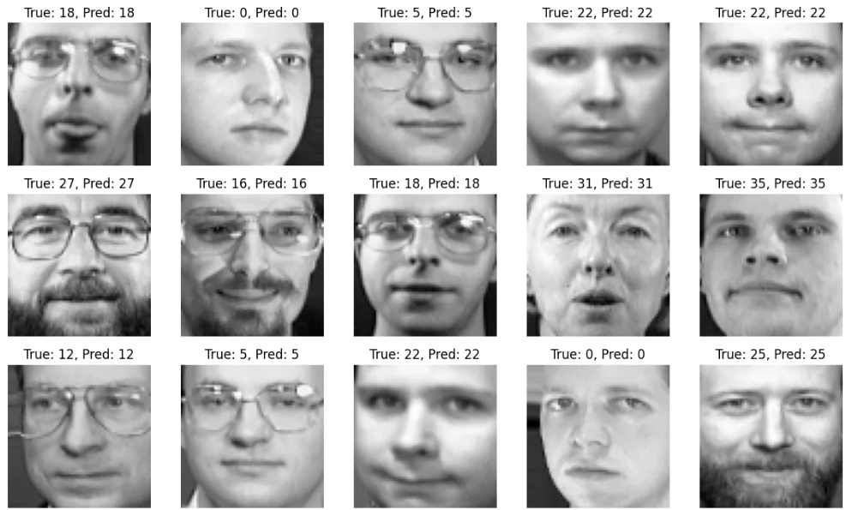

Accuracy: 80.83%
Classification Report:

precision recall f1-score support

0 0.67 1.00 0.80 2
1 1.00 1.00 1.00 2
2 0.33 0.67 0.44 3
3 1.00 0.00 0.00 5
4 1.00 0.50 0.67 4
5 1.00 1.00 1.00 2
7 1.00 0.75 0.86 4
8 1.00 0.67 0.80 3
9 1.00 0.75 0.86 4
10 1.00 1.00 1.00 3
11 1.00 1.00 1.00 1
12 0.40 1.00 0.57 4
13 1.00 0.80 0.89 5
14 1.00 0.40 0.57 5
15 0.67 1.00 0.80 2
16 1.00 0.67 0.80 3
17 1.00 1.00 1.00 3
18 1.00 1.00 1.00 3
19 0.67 1.00 0.80 2
20 1.00 1.00 1.00 3
21 1.00 0.67 0.80 3
22 1.00 0.60 0.75 5
23 1.00 0.75 0.86 4
24 1.00 1.00 1.00 3
25 1.00 0.75 0.86 4
26 1.00 1.00 1.00 2
27 1.00 1.00 1.00 5
28 0.50 1.00 0.67 2
29 1.00 1.00 1.00 2
30 1.00 1.00 1.00 2
31 1.00 0.75 0.86 4
32 1.00 1.00 1.00 2
34 0.25 1.00 0.40 1
35 1.00 1.00 1.00 5
36 1.00 1.00 1.00 3
37 1.00 1.00 1.00 1
38 1.00 0.75 0.86 4
39 0.50 1.00 0.67 5
accuracy 0.81 120
macro avg 0.89 0.85 0.83 120
weighted avg 0.91 0.81 0.81 120
Confusion Matrix:
[[2 0 0 ... 0 0 0]
[0 2 0 ... 0 0 0]
[0 0 2 ... 0 0 1]
...
[0 0 0 ... 1 0 0]
[0 0 0 ... 0 3 0]
[0 0 0 ... 0 0 5]]

Cross-validation accuracy: 87.25%
Program 10
Develop a program to implement k-means clustering using Wisconsin Breast Cancer data set and visualize the clustering result.
import numpy as np
import pandas as pd
import matplotlib.pyplot as plt
import seaborn as sns
from sklearn.datasets import load_breast_cancer
from sklearn.cluster import KMeans
from sklearn.preprocessing import StandardScaler
from sklearn.decomposition import PCA
from sklearn.metrics import confusion_matrix, classification_report

data = load_breast_cancer()
X = data.data
y = data.target

scaler = StandardScaler()
X_scaled = scaler.fit_transform(X)

kmeans = KMeans(n_clusters=2, random_state=42)
y_kmeans = kmeans.fit_predict(X_scaled)

print("Confusion Matrix:")
print(confusion_matrix(y, y_kmeans))
print("\nClassification Report:")
print(classification_report(y, y_kmeans))

pca = PCA(n_components=2)
X_pca = pca.fit_transform(X_scaled)

df = pd.DataFrame(X_pca, columns=['PC1', 'PC2'])
df['Cluster'] = y_kmeans
df['True Label'] = y

plt.figure(figsize=(8, 6))
sns.scatterplot(data=df, x='PC1', y='PC2', hue='Cluster', palette='Set1', s=100, edgecolor='black', alpha=0.7)
plt.title('K-Means Clustering of Breast Cancer Dataset')
plt.xlabel('Principal Component 1')
plt.ylabel('Principal Component 2')
plt.legend(title="Cluster")
plt.show()

plt.figure(figsize=(8, 6))
sns.scatterplot(data=df, x='PC1', y='PC2', hue='True Label', palette='coolwarm', s=100, edgecolor='black', alpha=0.7)
plt.title('True Labels of Breast Cancer Dataset')
plt.xlabel('Principal Component 1')
plt.ylabel('Principal Component 2')
plt.legend(title="True Label")
plt.show()

plt.figure(figsize=(8, 6))
sns.scatterplot(data=df, x='PC1', y='PC2', hue='Cluster', palette='Set1', s=100, edgecolor='black', alpha=0.7)
centers = pca.transform(kmeans.cluster_centers_)
plt.scatter(centers[:, 0], centers[:, 1], s=200, c='red', marker='X', label='Centroids')
plt.title('K-Means Clustering with Centroids')
plt.xlabel('Principal Component 1')
plt.ylabel('Principal Component 2')
plt.legend(title="Cluster")
plt.show()

Output:
